Phase 3 – Prototyping, Testing & Reflection

Fabrication Details

Legs:
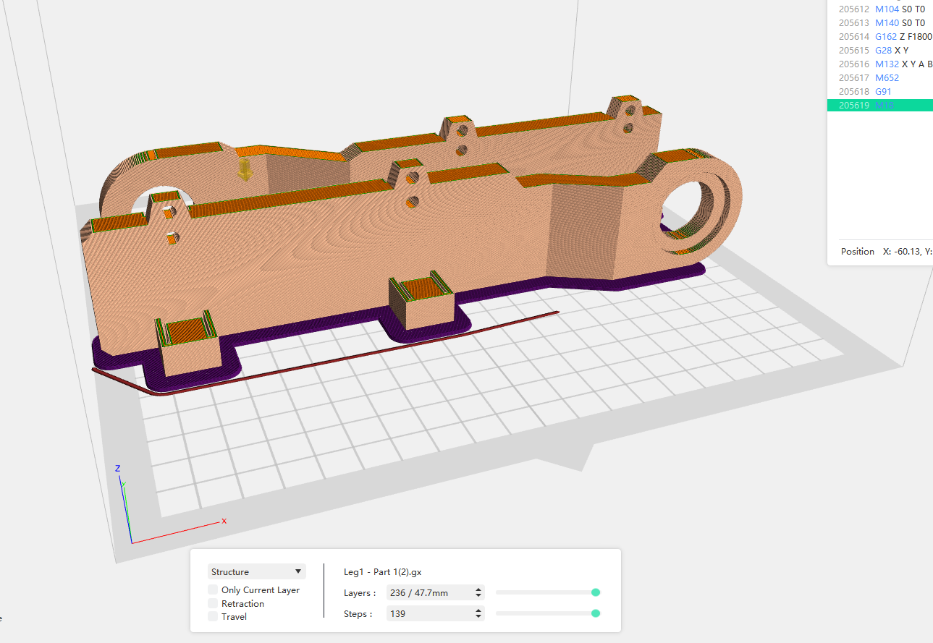

  - Printer and Material
  - Printer:
  - Filament: PLA
  - 4 top layers and 3 bottom layers
  - Infill: 15%
  - Supports: None
  - Orientation: Standing on plate vertical
  - Print details: PLA material used

Pins:
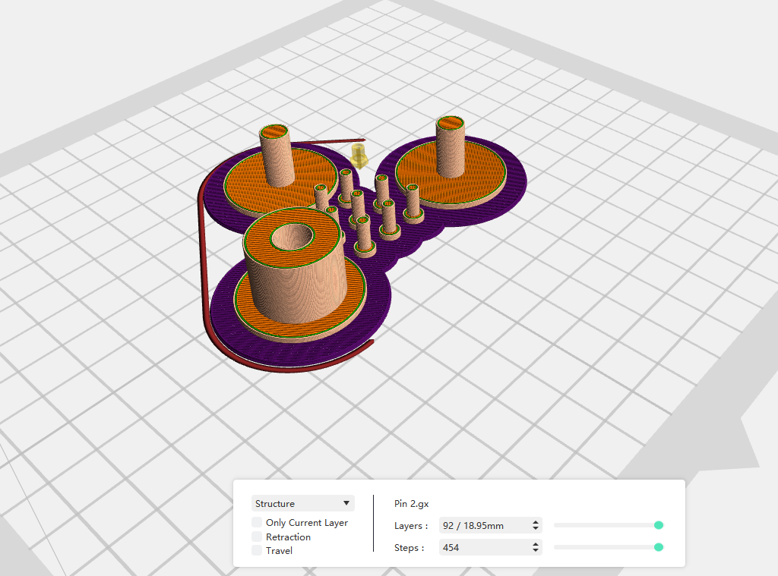
  - Printer and Material
  - Printer:
  - Filament: PLA
  - 4 top layers and 3 bottom layers
  - Infill: 100%
  - Supports: None
  - Orientation: Standing on plate vertical
Straps:
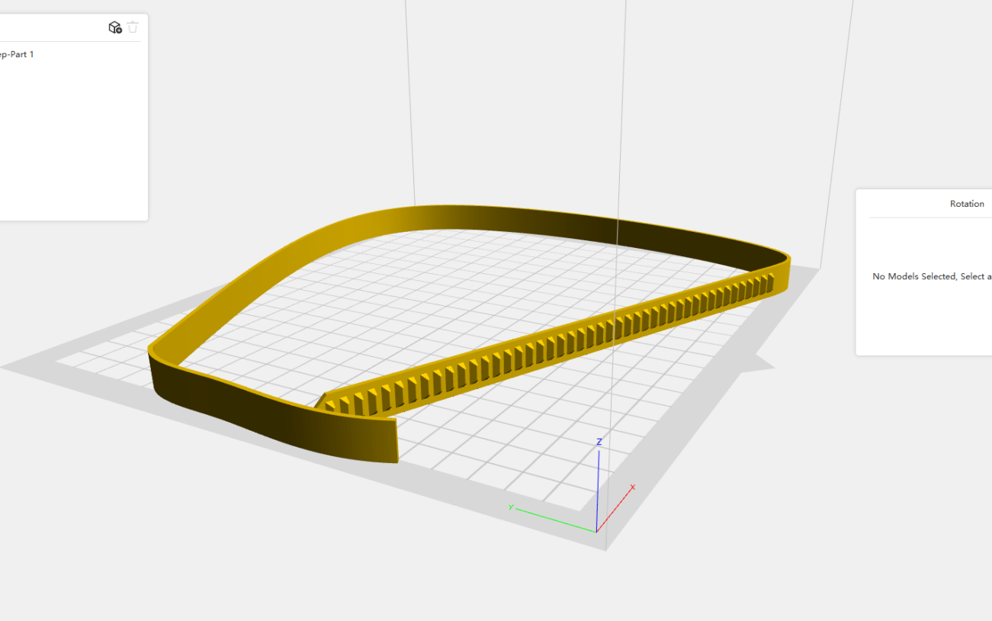
  - Printer and Material
  - Printer:
  - Filament: TPU
  - 4 top layers and 3 bottom layers
  - Infill: 15%
  - Supports: None
  - Orientation: Standing on plate vertical
  - Note: printed with cooling fan off as TPU requires this condition to print properly

Assembly Procedure and Challenges

Assembly Steps:
(list the steps here and photos)

Challenges that we encountered:
The first issue we came across was that the straps were not sized correctly, so they wouldn't fit the actual model, and we couldn't attach them to our prototype. We also had issues with birds nesting in the 3D printers while we were redoing our designs. And when it came down to our first design, we had an issue with unexpected stiffness, and that was not as stiff as we wanted.

Test procedures, Results, and Interpretation
- Design simple tests to demonstrate key functions (e.g., smooth rotation under
load, torque transmission, speed ratio, backlash, ability to lift a given weight).

- Collect and report qualitative and/or quantitative data (e.g., maximum load before
skipping, measured angle vs. expected angle, qualitative smoothness).
Interpretation :

In order to verify the performance of the brace, several prototype tests were performed to understand the success of the brace based on project objectives. The main tests needed to demonstrate success revolve a smooth rotation test, load support test, strap fit test, strap clasp test, and fatigue test.

Test 1: Smooth Rotation
Test 2: Load Support
Test 3: Strap Fit
Test 4: Strap Clast
Test 5: Fatigue Test
Test 6: Lateral Motion Resistance Test

Comparison with Phase 2 predictions (where applicable)
In Phase 2, the brace was analyzed in ANSYS to predict its behavior under the expected loading conditions. The simulation showed low stress levels and a safety factor greater than 1, indicating that the brace was unlikely to fail structurally. However, the deformation results revealed that one side of the brace had significantly more displacement than the other. This suggested that stiffness could become an issue during prototyping. In Phase 3, this was confirmed when the first printed prototype turned out to be more flexible than anticipated, particularly in the upper and lower leg plates. This indicated that while the design was structurally safe in simulation, the physical prototype did not behave the same way due to factors like print thickness, infill percentage, layer orientation, and material behavior.

Another major difference between the Phase 2 model and the Phase 3 prototype was how the assembled parts fit together. In CAD, the hinge, pin, holes, and mating features fit as planned since the model assumed perfect dimensions. Once printed, however, some areas were too tight while others were a bit loose due to 3D-printing tolerances. For instance, the hinge hole and pin did not have enough clearance, which could cause friction or binding during movement. Overall, the main incorrect assumptions were that the printed parts would exactly match the CAD model and that the hinge and strap features would fit properly without adjustment. For Version 2, the design should include thicker plates, adjusted hinge clearances, modified hole sizes, and improved strap placement to increase stiffness, enhance assembly, and reduce slipping during use.

Failures, mistakes, and surprises
One of the biggest surprises in Phase 3 was translating the simulated model into a physical 3D-printed prototype. The simulations assumed ideal geometry, material behavior, and connections, but the printed prototype introduced issues that were not fully shown in the model. One of the main issues was the stiffness of the leg plates, which depended on print settings such as infill percentage, print orientation, and overall thickness. Another unexpected issue was how much 3D-printing tolerances affected assembly. In ANSYS and OnShape, the parts fit together perfectly, but once printed and assembled, some areas were too tight while others were too loose. For example, there was not enough clearance between the hinge hole and pin, which caused binding during motion. These issues showed that the prototype needed additional clearance, thicker structural features, and better consideration of manufacturing tolerances before testing.

Reprints
We needed to do one reprint based off of the design issue of stiffness and sizing. Our first model was flexible when we needed to be stiff and there's a miscalculation when it came to the actual sizing of our prototype. We also needed to change the thickness and scale of the sizing to help give it the stiffness that we were looking for. We also added one more leg strap. In this case it would order us to make it not slide on the user's leg and for better comfort.

Design Changes for Version 2
- The primary design modification implemented in Phase 3 was increasing the thickness of the upper and lower plates. This change was made in response to the Phase 2 simulation results, which showed relatively high deformation (approximately 3 mm) on one side of the brace. This indicated that the structure did not have sufficient stiffness to resist bending under the applied load.
- The clearance between the hinge shaft and the hole was adjusted to reduce friction and prevent binding during motion. This ensured smoother flexion and extension of the joint while maintaining proper alignment.
- Hole sizes and mating features were modified to account for 3D printing tolerances, reducing looseness and improving assembly quality.
- Increasing plate thickness significantly improved stiffness and reduced deformation. The updated design shows low stress levels and high factors of safety, confirming structural reliability. Overall, the system achieves its intended function and provides a strong foundation.

